**Project Title:** Market Basket Analysis

**Problem Statement**

**Problem Definition:** The problem is to perform market basket analysis on a provided dataset to unveil hidden patterns and associations between products. The goal is to understand customer purchasing behavior and identify potential cross-selling opportunities for a retail business. This project involves using association analysis techniques, such as Apriori algorithm, to find frequently co-occurring products and generate insights for business optimization

1. **Data Collection and Preprocessing:**
   * Obtain the dataset containing transaction records.
   * Clean and preprocess the data, ensuring it is in a suitable format for analysis.





1. **Exploratory Data Analysis (EDA):**
   * Conduct initial data exploration to understand the basic statistics and characteristics of the dataset.
2. **Market Basket Analysis:**
   * Implement the Apriori algorithm or similar association analysis techniques to find frequent itemsets and association rules.
   * Determine key metrics such as support, confidence, and lift to evaluate the strength of associations.
3. **Visualization and Interpretation:**
   * Visualize the discovered associations using appropriate charts and graphs.
   * Interpret the results to extract meaningful insights, such as which products are frequently bought together or which combinations have the highest lift.

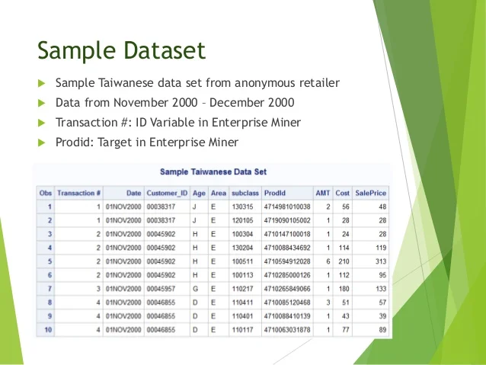

1. **Business Recommendations:**
   * Provide actionable recommendations based on the analysis, such as product bundling or marketing strategies.
   * Identify cross-selling opportunities to increase sales and customer satisfaction.
2. **Documentation and Reporting:**
   * Document the entire analysis process, including data preprocessing, modeling, and interpretation.
   * Create a comprehensive report summarizing the findings and recommendations for stakeholders.

